Loan Approval MapReduce Project

Read the data from HDFS using a MapReduce job.
Group records by the categorical column.
Perform an aggregation (e.g., sum, average, max, min, or count) on the numerical column.
Store the final aggregated results in a new HDFS directory.
(Optional) Sort the output based on the aggregated value.

🧮 Sample Analytics Use Cases (Choose any one or define your own):
Total sales per product
Average salary per department
Total quantity per region
Count of records per category
Max/min value per group

🧪 Requirements

The MapReduce job must run end-to-end on a Hadoop cluster.
Input file must be read from HDFS.
Output must be stored back in HDFS.
Mapper and Reducer should be generic enough to work with any CSV file, with only column positions configurable.

Login to the console: with ssh
Set up the project folder and upload dataset.csv
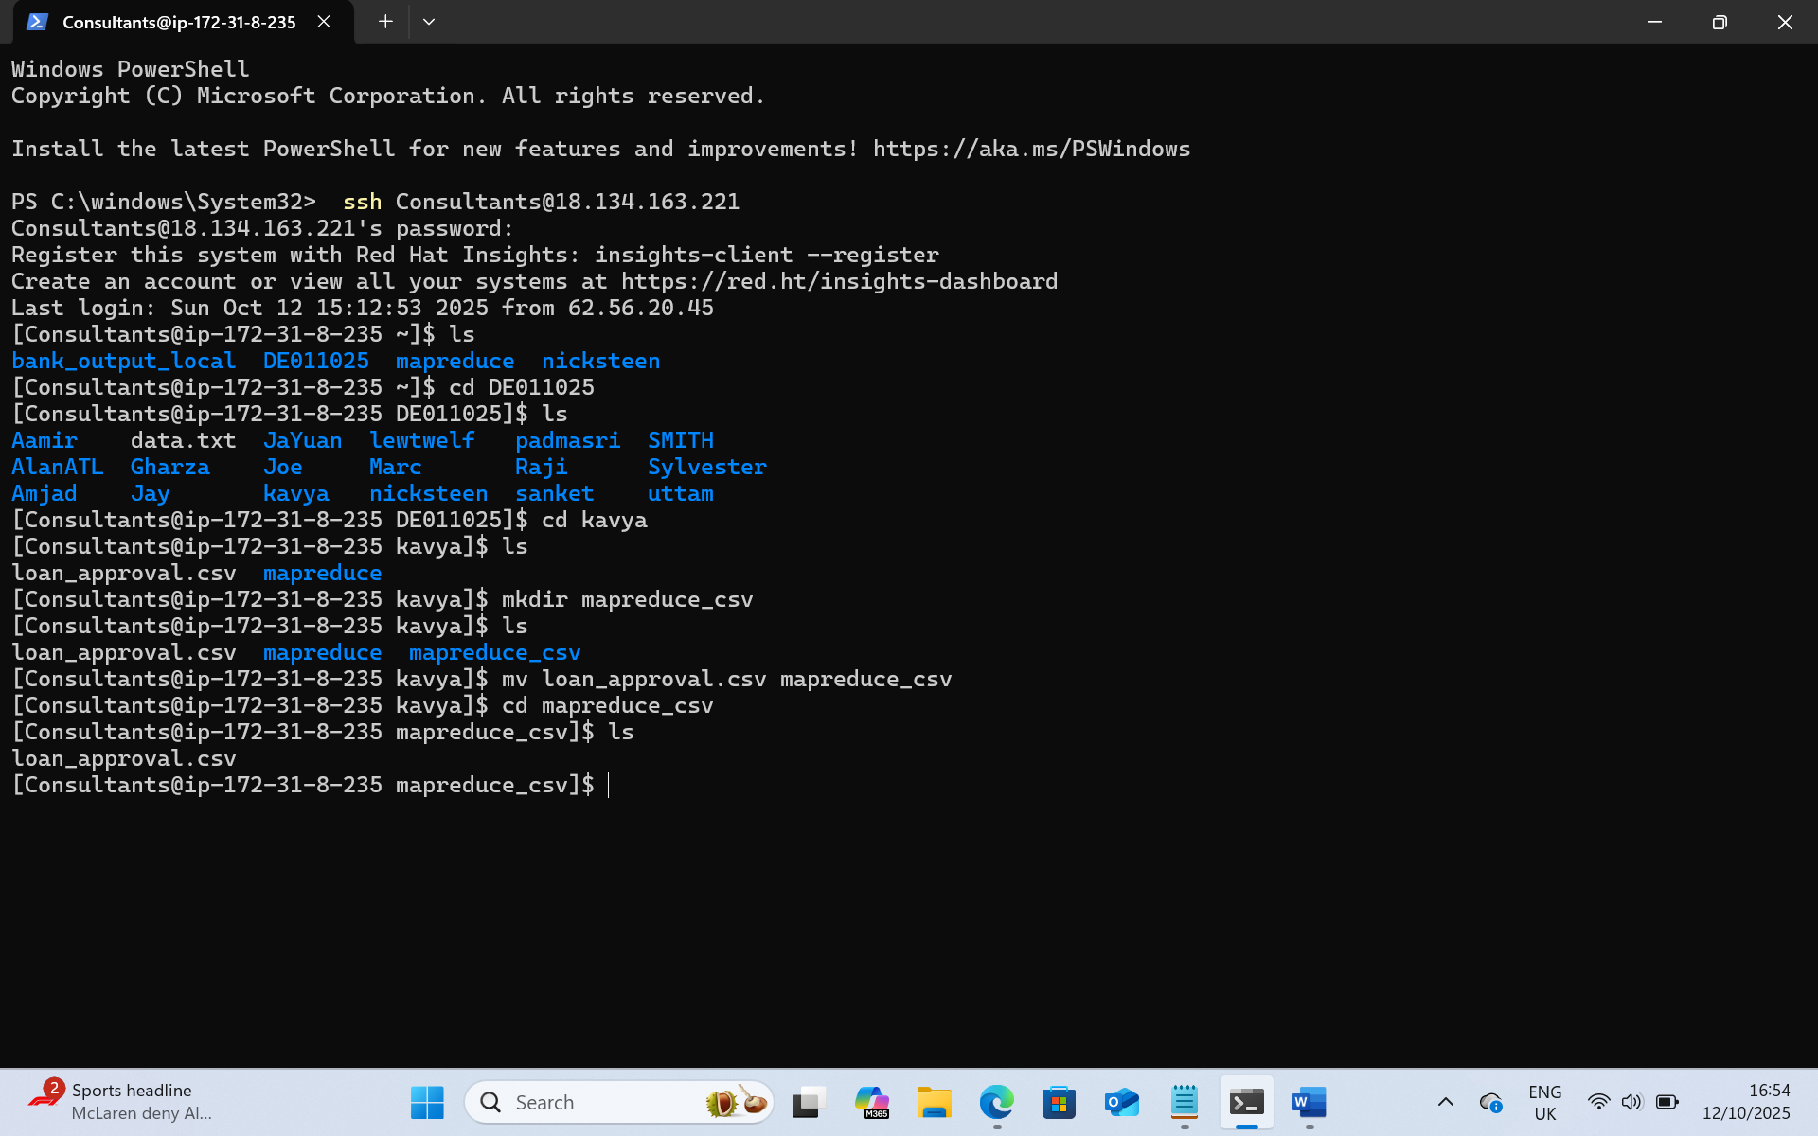

Set HDFS work space

hdfs dfs -mkdir -p /tmp/DE011025/kavya/input
hdfs dfs -mkdir -p /tmp/DE011025/kavya/output

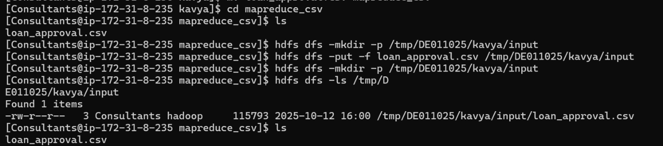

Read the data from HDFS using a MapReduce job.
- Display a table head of 10
hdfs dfs -cat /tmp/DE011025/kavya/input/loan_approval.csv | head -n 10 | column -t -s ','
# hdfs dfs -cat – read file from HDFS
# head -n 10 – first 10 rows of data
# column -t -s ‘,’ --- format in table set comma as separator.

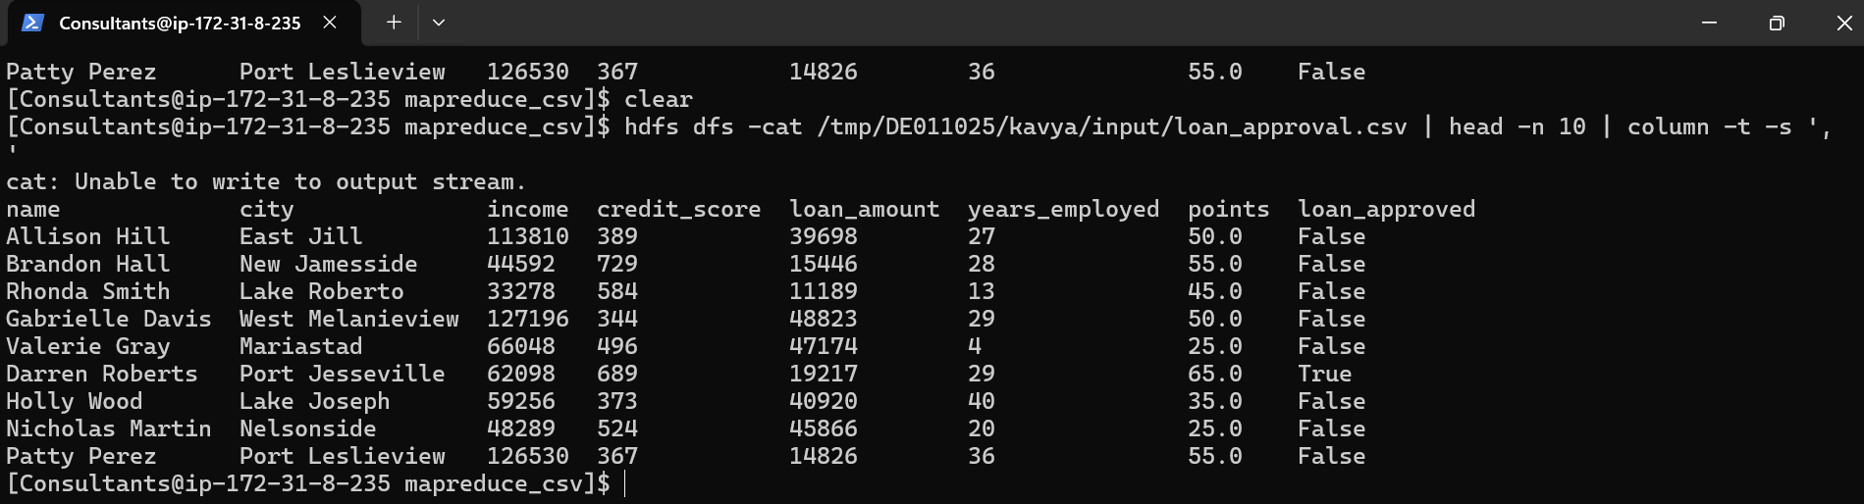

hdfs dfs -cat /tmp/DE011025/kavya/input/loan_approval.csv | head -n 1 | tr ',' '\n' | nl -v 0
head -n 1 shows only first line, usually in csv first column is header.
tr ‘,’ ‘\n’ : translate charaters replace with comma with a new line.
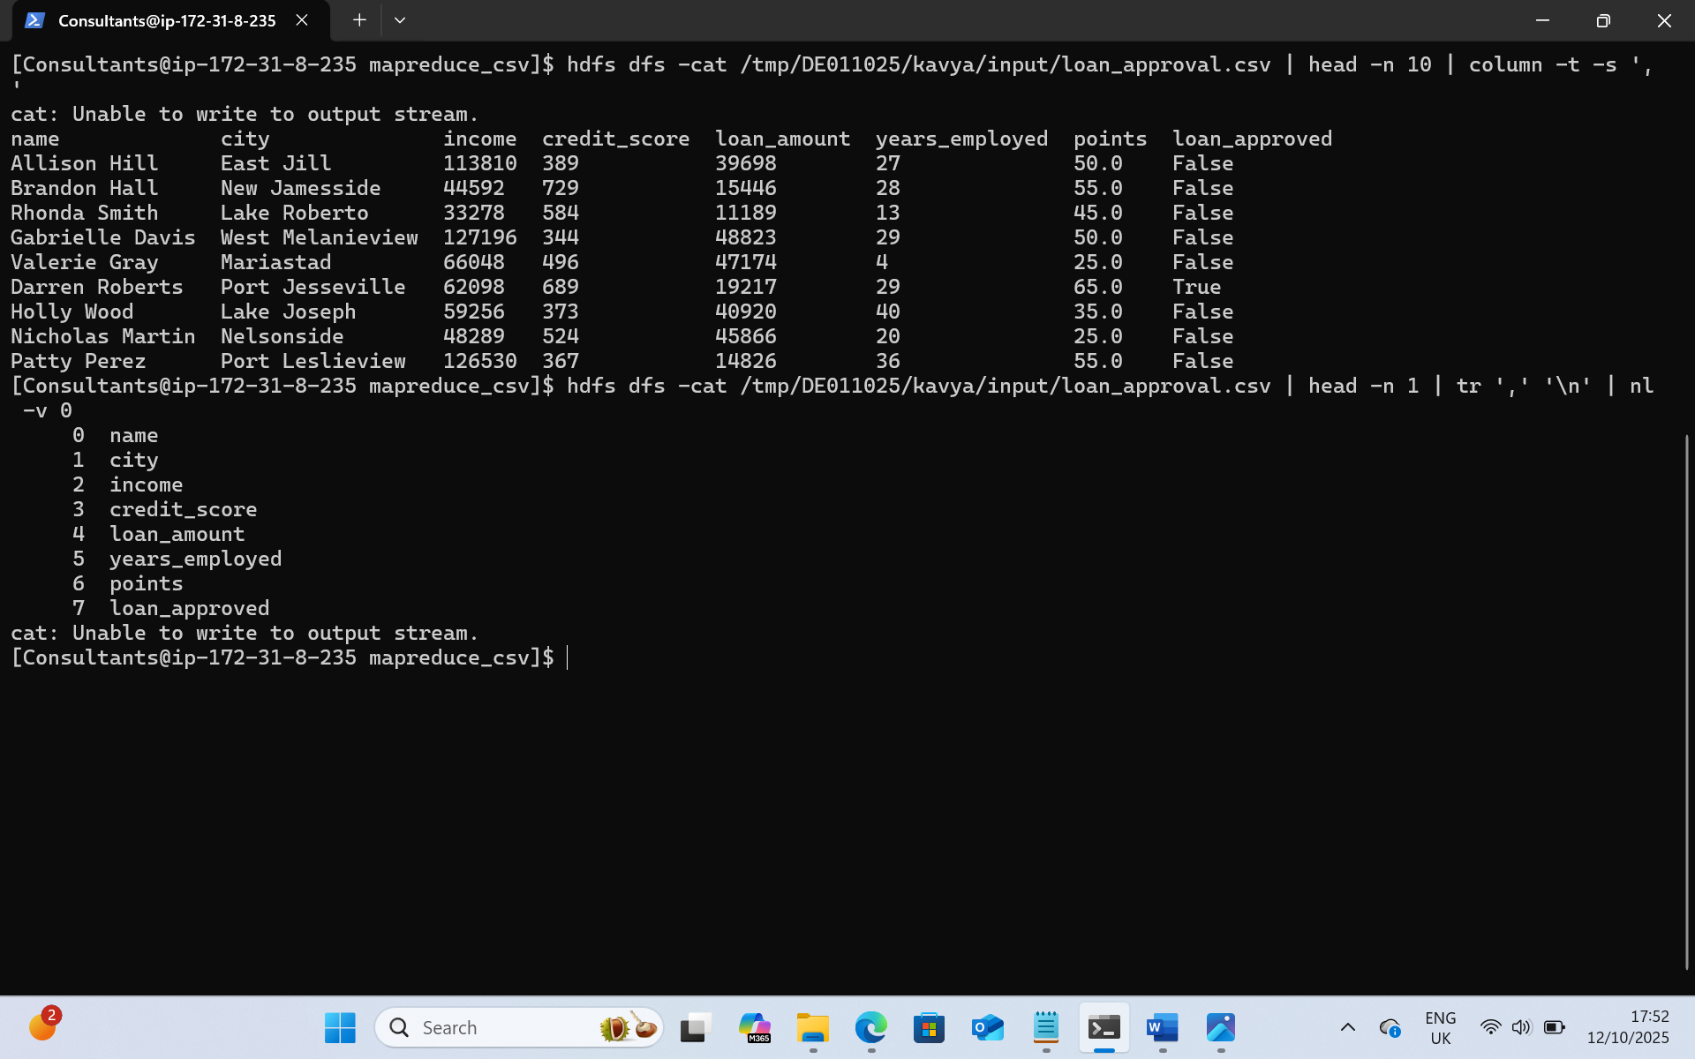
Definitions:
- HDFS (Hadoop Distributed File System): Cluster file system where your input CSV lives and where MapReduce writes results.
- MapReduce: A two-phase processing model:
  - Mapper: reads rows, emits <key, value>. (e.g., <Property_Area, ApplicantIncome> or <Loan_Status, 1>).
  - Reducer: receives all values for the same key and aggregates (sum/avg/min/max/count).
- Hadoop Streaming: Lets you write mapper/reducer in any language (we use Python) and run them as a MapReduce job.
- YARN: Cluster resource manager that schedules your MapReduce containers.
- InputSplit & RecordReader: Internals that split big files and parse lines so each mapper gets a chunk of rows.
- Shuffle & Sort: System step between map and reduce that groups the same keys together (all Property_Area=Urban rows go to the same reducer).
- Partitioner: Decides which reducer a key is sent to (default: hash of the key).
- Combiner (optional): Mini-reducer that runs on map output to cut network traffic (safe for sum/count/min/max).
- OutputFormat: How results are written (default: tab-separated text files part-* in an HDFS directory).

Mapper.py:
#!/usr/bin/env python #Tells Hadoope to run this file with python
from __future__ import print_function # print function
import os, sys, csv # os – read environmental variables, sys – read i/p from Hadoop standard input(stdin), csv-parses comma separates values safely.
GROUP_COL = int(os.getenv("GROUP_COL", "0"))
NUM_COL = os.getenv("NUM_COL", "").strip()
AGG = os.getenv("AGG", "sum").lower()
HAS_HEADER= os.getenv("HAS_HEADER", "true").lower()

#Converts NUM_COL to an integer,
or sets num_idx = None if there is no numeric column (for count operations).
num_idx = None if NUM_COL in ("", "none", "-1") else int(NUM_COL)

#Creates a CSV reader to parse each incoming line from Hadoop’s standard input.
reader = csv.reader(sys.stdin)
#Loops over each CSV row (record).
first = True
for row in reader:
#Skips empty lines to avoid processing errors.
if not row:
continue
# if first like in dataset header skip, after first iteration first coloumn is false
if first and HAS_HEADER == "true":
first = False
continue
first = False
#Safety check: if the row is shorter than expected (missing columns), skip it.
if GROUP_COL >= len(row):
continue
# Extracts the grouping key (eg True, False for loan approval)
key = row[GROUP_COL].strip()
# For count operations, emits one record per row with a value of 1.
if AGG == "count" or num_idx is None:
print("%s\t%s" % (key, 1))
continue
#Another safety check: skip if the numeric column index is invalid.
if num_idx >= len(row):
continue
# •Converts the numeric field to a float (e.g., loan_amount = 200000.0).Emits the key–value pair to Hadoop
try:
val = float(row[num_idx])
print("%s\t%s" % (key, val))
except:
continue

reducer.py:
#Read desired aggregation type again so reducer knows what to compute.
#!/usr/bin/env python
AGG = os.getenv("AGG", "sum").lower()

#initialize variables for the currect group key and running tool.
current_key = None
count = 0
sumv = 0.0
maxv = None
minv = None
# defining fun flush() that prints aggregate result for one key once all its rows are processed.
def flush(k):
if k is None:
return
#print total count per key
if AGG == "count":
print("%s\t%s" % (k, count))
#print total sum per key
elif AGG == "sum":
print("%s\t%s" % (k, sumv))
#avg
elif AGG == "avg":
out = (sumv / count) if count else 0.0
print("%s\t%s" % (k, out))
#max
elif AGG == "max":
print("%s\t%s" % (k, "" if maxv is None else maxv))
#min
elif AGG == "min":
print("%s\t%s" % (k, "" if minv is None else minv))
else:
print("%s\t%s" % (k, sumv))

# reads mapper outputline, split each (key,value) pain into k key v value
for line in sys.stdin:
parts = line.rstrip("\n").split("\t", 1)
if len(parts) != 2:
continue
k, v = parts
#When a new key starts, initialize the running totals.
if current_key is None:
k, v = parts
if current_key is None:
current_key = k
count = 0
sumv = 0.0
maxv = None
minv = None
#•Hadoop sends sorted input to the reducer, so when the key changes, the old group is complete. flush() prints the result for that completed key.

if k != current_key:
flush(current_key)
current_key = k
count = 0
sumv = 0.0
maxv = None
minv = None
# For count aggregation, just increment by one per record.
if AGG == "count":
count += 1
#Converts the value to a float. Updates running sumv, maxv, and minv. Also increments count (used for average).
else:
try:
fv = float(v)
except:
continue
count += 1
sumv += fv
maxv = fv if (maxv is None or fv > maxv) else maxv
minv = fv if (minv is None or fv < minv) else minv

#After reading all lines, flushes the final key’s result.
flush(current_key)

Group records by the categorical column.
Loan approval by count : tells How many applications got loan approval (True) and did not got loan approval(False)

- This JAR provides a bridge so Hadoop can execute your Python mapper and reducer scripts as MapReduce jobs. Runs the Hadoop Streaming JAR located in your Cloudera parcel path. hadoop jar executes any MapReduce job packaged as a .jar. Hadoop Streaming allows using Python scripts instead of Java.
hadoop jar /opt/cloudera/parcels/CDH/lib/hadoop-mapreduce/hadoop-streaming.jar \

# sets job name in yarn, make it easy to identify job among other running on cluster
-D mapreduce.job.name="Max income by approval" \
# providing scripts mapper.py and reducer.py
-files mapper.py,reducer.py \
#start mapper process send , emits coloumn 7, num_col 0 , key-value pairs via stdout
-mapper "python mapper.py" \
#specifies program Agg = count,
-reducer "python reducer.py" \
-input /tmp/DE011025/kavya/input/loan_approval.csv \
-output /tmp/DE011025/kavya/output/count_by_approval \
-cmdenv GROUP_COL=7 \ #index 7 coloumn
-cmdenv NUM_COL=none \ #none
-cmdenv AGG=count \ #agg = count
-cmdenv HAS_HEADER=true # skip header

View Result:

hdfs dfs -ls /tmp/DE011025/kavya/output/count_by_approval
hdfs dfs -cat /tmp/DE011025/kavya/output/count_by_approval/part-00000/1
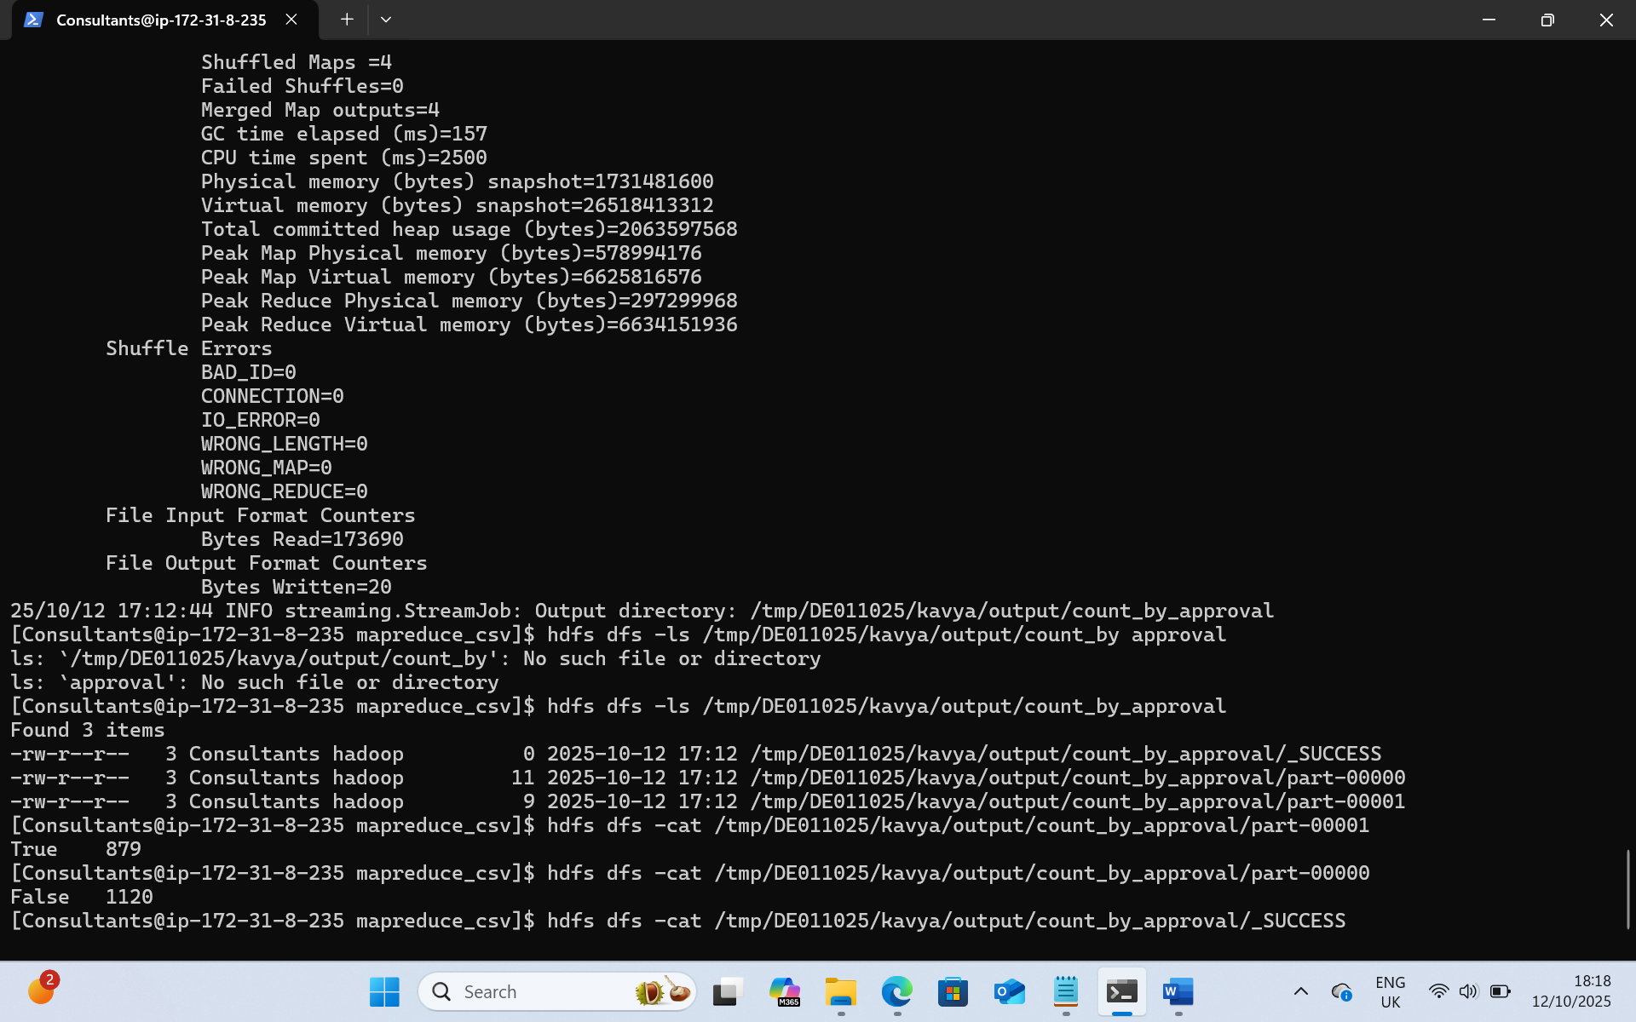
True – 879 , False – 1120

Max income per loan approved
- Runs the Hadoop Streaming JAR located in your Cloudera parcel path.
- hadoop jar executes any MapReduce job packaged as a .jar.
- Hadoop Streaming allows using Python scripts instead of Java.
This JAR provides a bridge so Hadoop can execute your Python mapper and reducer scripts as MapReduce jobs

hadoop jar /opt/cloudera/parcels/CDH/lib/hadoop-mapreduce/hadoop-streaming.jar \

# sets job name in yarn, make it easy to identify job among other running on cluster
-D mapreduce.job.name="Max income by approval" \
# providing scripts mapper.py and reducer.py
-files mapper.py,reducer.py \
#start mapper process send , emits coloumn 7, num_col 2 , key-value pairs via stdout
-mapper "python mapper.py" \
#specifies program Agg = max,
-reducer "python reducer.py" \
-input /tmp/DE011025/kavya/input/loan_approval.csv \ # i/p location
-output /tmp/DE011025/kavya/output/max_income_by_approval \ #o/p location
-cmdenv GROUP_COL=7 -cmdenv NUM_COL=2 -cmdenv AGG=max -cmdenv HAS_HEADER=true

View Result:
hdfs dfs -ls/tmp/DE011025/kavya/output/max_income_by_approval
hdfs dfs -cat /tmp/DE011025/kavya/output/max_income_by_approval/part-*
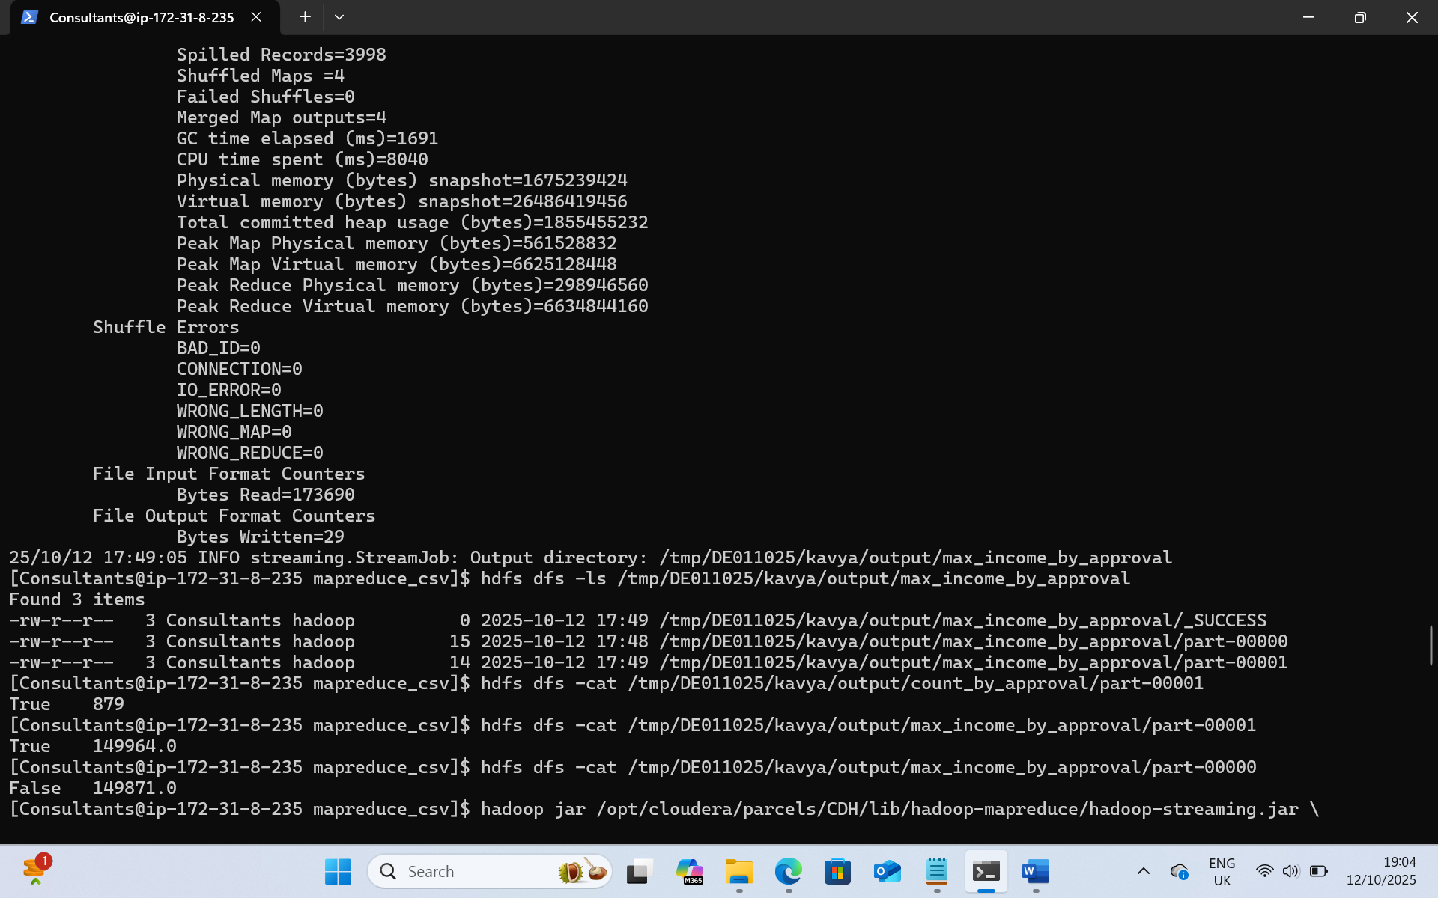

Total loan approved:

hadoop jar /opt/cloudera/parcels/CDH/lib/hadoop-mapreduce/hadoop-streaming.jar \
-D mapreduce.job.name="Total Loan Amount" \
-files mapper.py,reducer.py \
-mapper "python mapper.py" \
-reducer "python reducer.py" \
-input /tmp/DE011025/kavya/input/loan_approval.csv \
-output /tmp/DE011025/kavya/output/total_loan_amount \
-cmdenv GROUP_COL=7 \
-cmdenv NUM_COL=4 \
-cmdenv AGG=sum \
-cmdenv HAS_HEADER=true
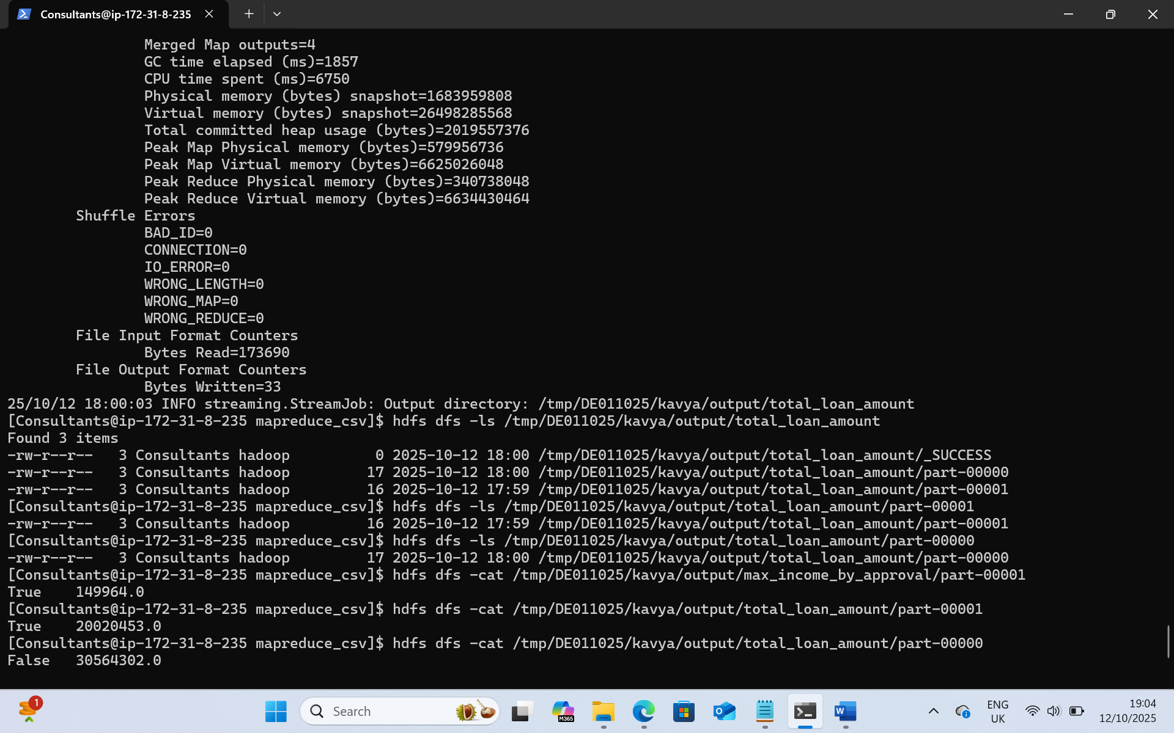

View Result:
hdfs dfs -cat /tmp/DE011025/kavya/output/max_loanamt_by_approval/part-*

